CPE301 – SPRING 2019

MIDTERM 1

Student Name: Victor Martinez

Student #: 5003131674

Student Email: [martiv6@unlv.nevada.edu](mailto:martiv6@unlv.nevada.edu)

Primary Github address: <https://github.com/martiv6/>

Directory: <https://github.com/martiv6/>midterms/Midterm_1

Submit the following for all Labs:

1. In the document, for each task submit the modified or included code (only) with highlights and justifications of the modifications. Also, include the comments.
2. Use the previously create a Github repository with a random name (no CPE/301, Lastname, Firstname). Place all labs under the root folder ESD301/Midterm, sub-folder named LABXX, with one document and one video link file for each lab, place modified asm/c files named as LabXX-TYY.asm/c.
3. If multiple asm/c files or other libraries are used, create a folder LabXX-TYY and place these files inside the folder.
4. The folder should have a) Word document (see template), b) source code file(s) and other include files, c) text file with youtube video links (see template).

1. **COMPONENTS LIST AND CONNECTION BLOCK DIAGRAM w/ PINS**

ESP-01

TEMP Sensor

BREAD

BOARD

328P

Mini

POWERSUPPLY

1. **INITIAL/MODIFIED/DEVELOPED CODE OF TASK 1/A**

/*

* Midterm.c

*

* Created: 4/1/2019 1:47:30 PM

* Author : victor

*/

#define *F_CPU* 16000000UL

#define BAUD 9600

#define MYUBRR *F_CPU*/16/BAUD-1

#include <avr/io.h>

#include <util/delay.h>

#include <stdio.h>

#include <avr/interrupt.h>

#include <stdlib.h>

void read_adc(void); // where the adc is read

void adc_initializer(void); // where the ADC initializes

void USART_init( unsigned int ubrr ); // where USART initializes

void USART_tx_string(char *data); // where it prints string USART

volatile unsigned int room_temp; // where we hold the value of the ADC

char outs[256]; // room we have to print

int main(void) {

adc_initializer(); // Initialize the ADC (Analog / Digital Converter)

USART_init(MYUBRR); // Initialize the USART (RS232 interface)

*_delay_ms*(500); // wait a bit

sei(); // global interrupt

while(1)

{

}

}

void adc_initializer(void) //initialize ADC

{

ADMUX = (0<<REFS1)| (1<<REFS0)|(0<<ADLAR)| // Reference Selection Bits

(0<<MUX2)| (1<<MUX1)| (0<<MUX0); // avcc - external cap at AREF

// ADC Left Adjust Result

// Analog Channel Selection Bits

// PC2 where we read from

ADCSRA = (1<<ADEN)| (0<<ADSC)| (0<<ADATE)| (0<<ADIF)| // ADC ENable

(0<<ADIE)| (1<<ADPS2)|(0<<ADPS1)| (1<<ADPS0);

// ADC Start Conversion

// ADC Auto Trigger Enable

// ADC Interrupt Flag

// ADC Interrupt Enable

// ADC Prescaler Select Bits

// ADC Prescaler select bits

// ADC input

// Timer/Counter1 Interrupt Mask Register

TIMSK1 |= (1<<TOIE1); // enable overflow interrupt

TCCR1B |= (1<<CS12)|(1<<CS10); // clock

TCNT1 = 49911; //((16MHz/1024)*1)-1 = 15624

}

void read_adc(void) // initialize to begin to read from the sensor

{

unsigned char i =4; // to keep track of input

room_temp = 0;

while (i--) {

ADCSRA |= (1<<ADSC); // used to start convo with chips

while(ADCSRA & (1<<ADSC));

room_temp+= ADC;

*_delay_ms*(50);

}

room_temp = room_temp / 8; // gets correct value displayed

}

/* INIT USART (RS-232) */

void USART_init( unsigned int ubrr ) {

UBRR0H = (unsigned char)(ubrr>>8);

UBRR0L = (unsigned char)ubrr;

UCSR0B |= (1 << TXEN0) | (1 << RXEN0)| ( 1 << RXCIE0); // Enable receiver, transmitter & RX interrupt

UCSR0C |= (1<<UCSZ01) | (1 << UCSZ00);

}

void USART_tx_string( char *data ) // used to print on to the screen

{

while ((*data != '\0')) {

while (!(UCSR0A & (1 <<UDRE0)));

UDR0 = *data;

data++;

}

}

ISR(TIMER1_OVF_vect) // timer overflow interrupt to delay for 1 second

{

unsigned char AT_CHECK[] = "AT\r\n"; // AT Commands

unsigned char CWMODE_SET[] = "AT+CWMODE=1\r\n"; // Set MODE

unsigned char CWJAP_LOGIN[] = "AT+CWJAP=\"MY_WIFI\",\"12345678\"\r\n"; // MUST CHANGE WIFI AND PASSWORD

unsigned char CIPMUX_SET[] = "AT+CIPMUX=0\r\n";

unsigned char CIPSTART_SEND[] = "AT+CIPSTART=\"TCP\",\"api.thingspeak.com\",80\r\n";

unsigned char CIPSEND_FINISH[] = "AT+CIPSEND=100\r\n";

*_delay_ms*(2500);

USART_tx_string(AT_CHECK); //send commands

*_delay_ms*(6000);

USART_tx_string(CWMODE_SET); //set mode

*_delay_ms*(6000);

USART_tx_string(CWJAP_LOGIN); //connect to Wifi

*_delay_ms*(16000);

USART_tx_string(CIPMUX_SET); //select MUX

*_delay_ms*(10000);

USART_tx_string(CIPSTART_SEND); //connect TCP

*_delay_ms*(10000);

USART_tx_string(CIPSEND_FINISH); //send size

*_delay_ms*(6000);

read_adc(); //read ADC

*snprintf*(outs,sizeof(outs),"GET https://api.thingspeak.com/update?api_key=XA1ZWJOD2BRUEVKD&field2=%3d\r\n", room_temp);// print it

USART_tx_string(outs); //send data

*_delay_ms*(10000);

TCNT1 = 49911; //reset

}

1. **SCHEMATICS**

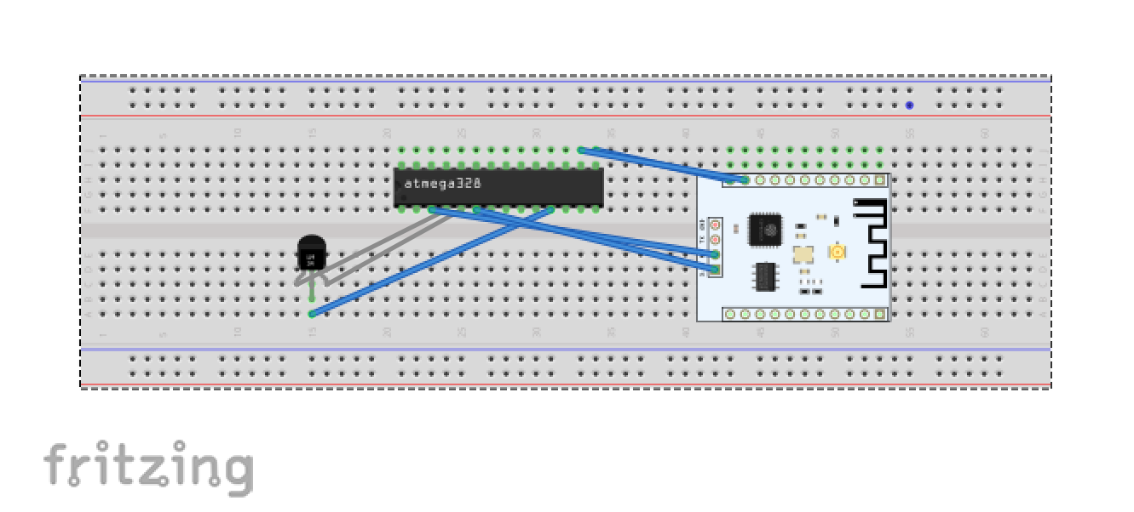

1. **SCREENSHOTS OF EACH TASK OUTPUT (ATMEL STUDIO OUTPUT)**

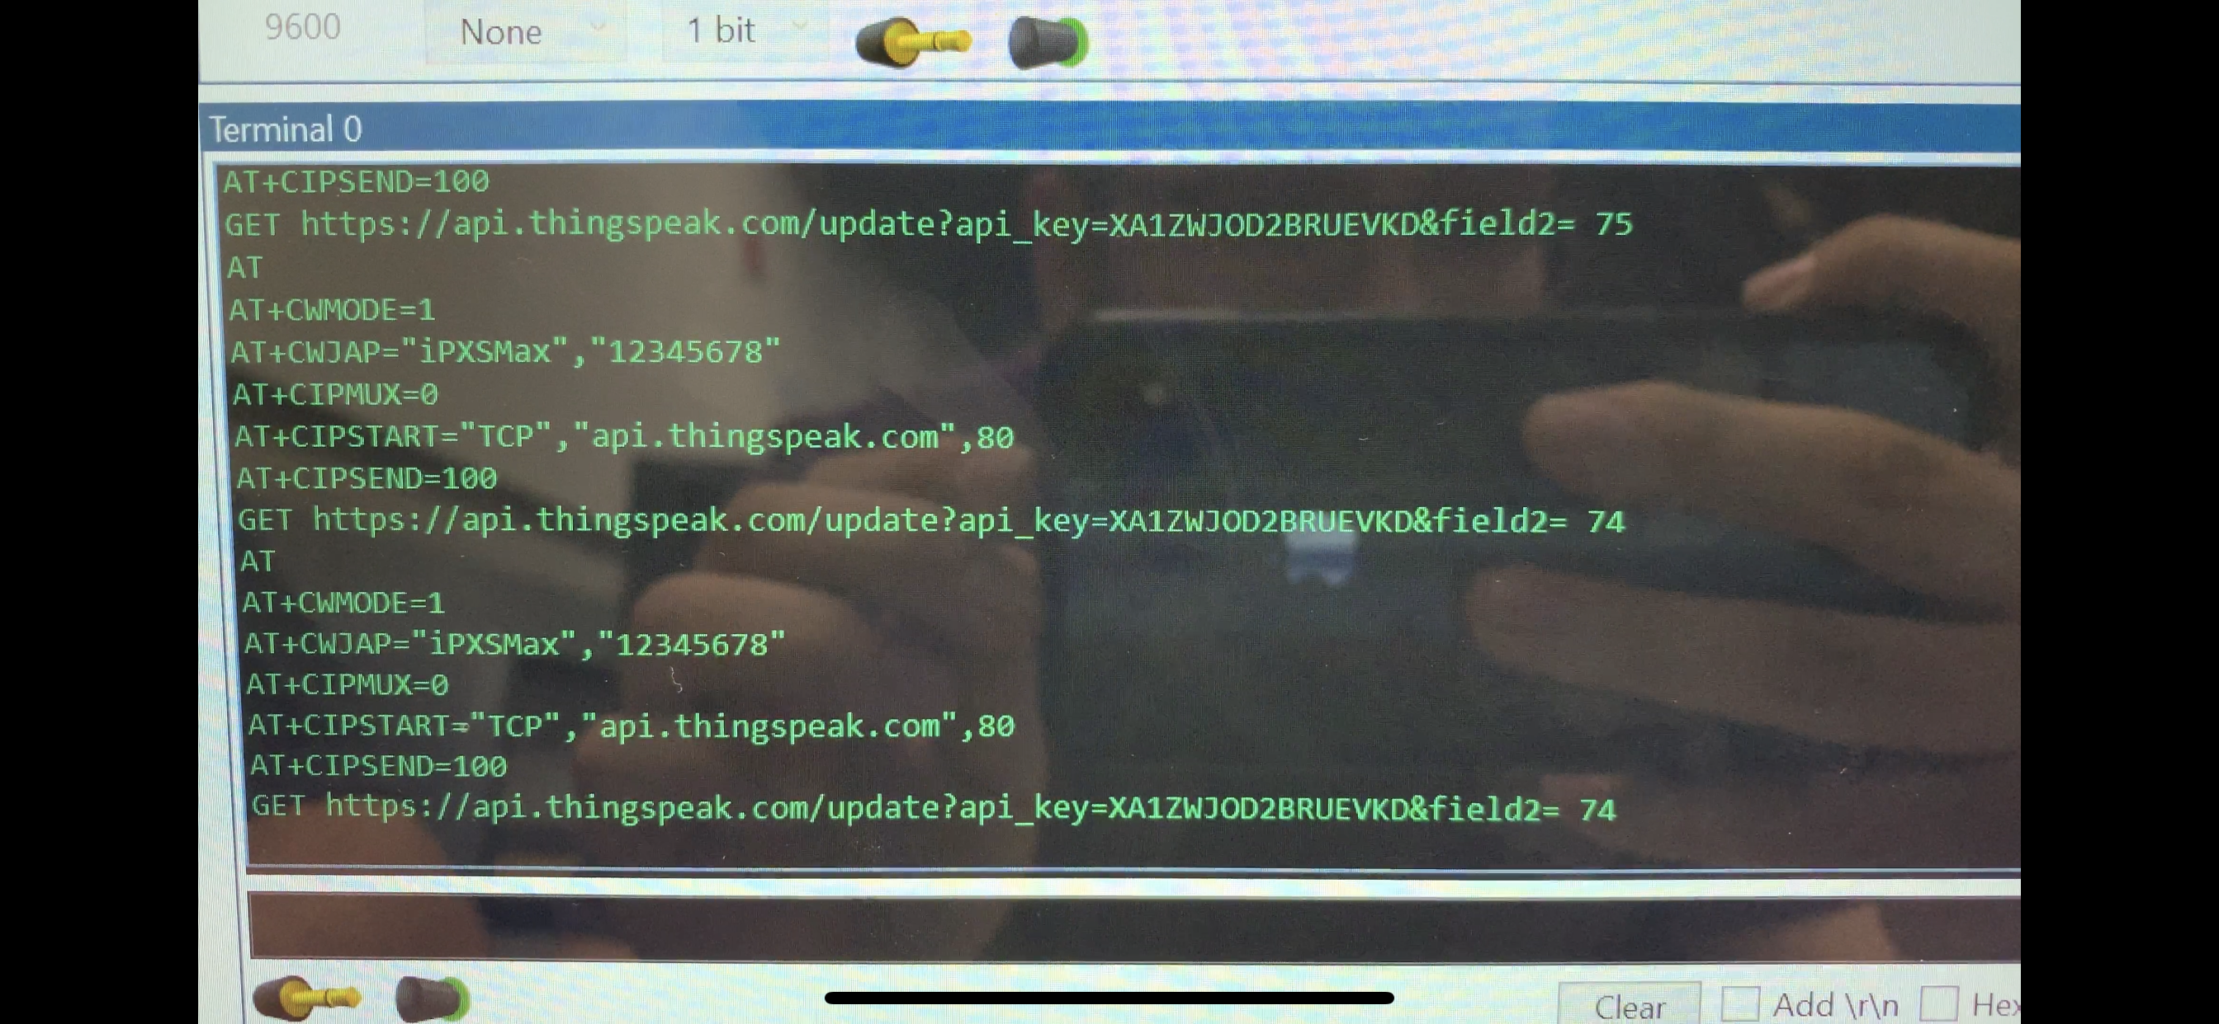

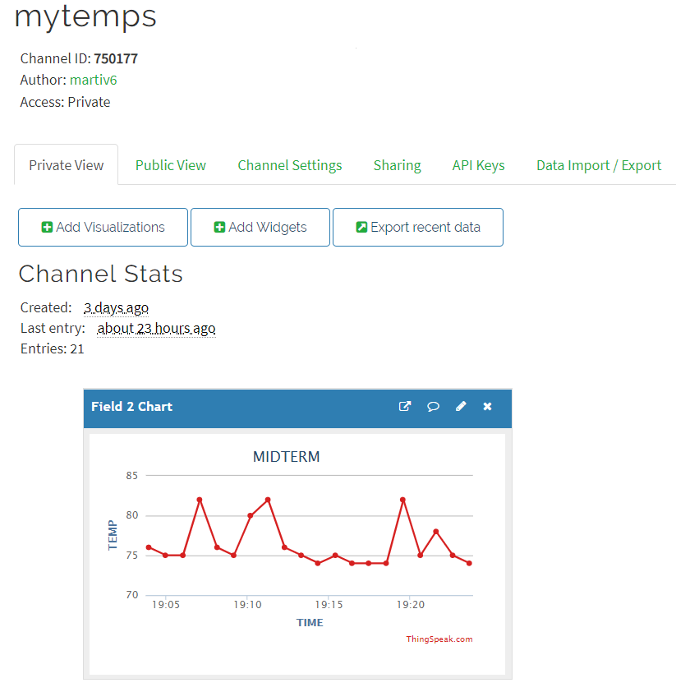

1. **SCREENSHOT OF EACH DEMO (BOARD SETUP)**

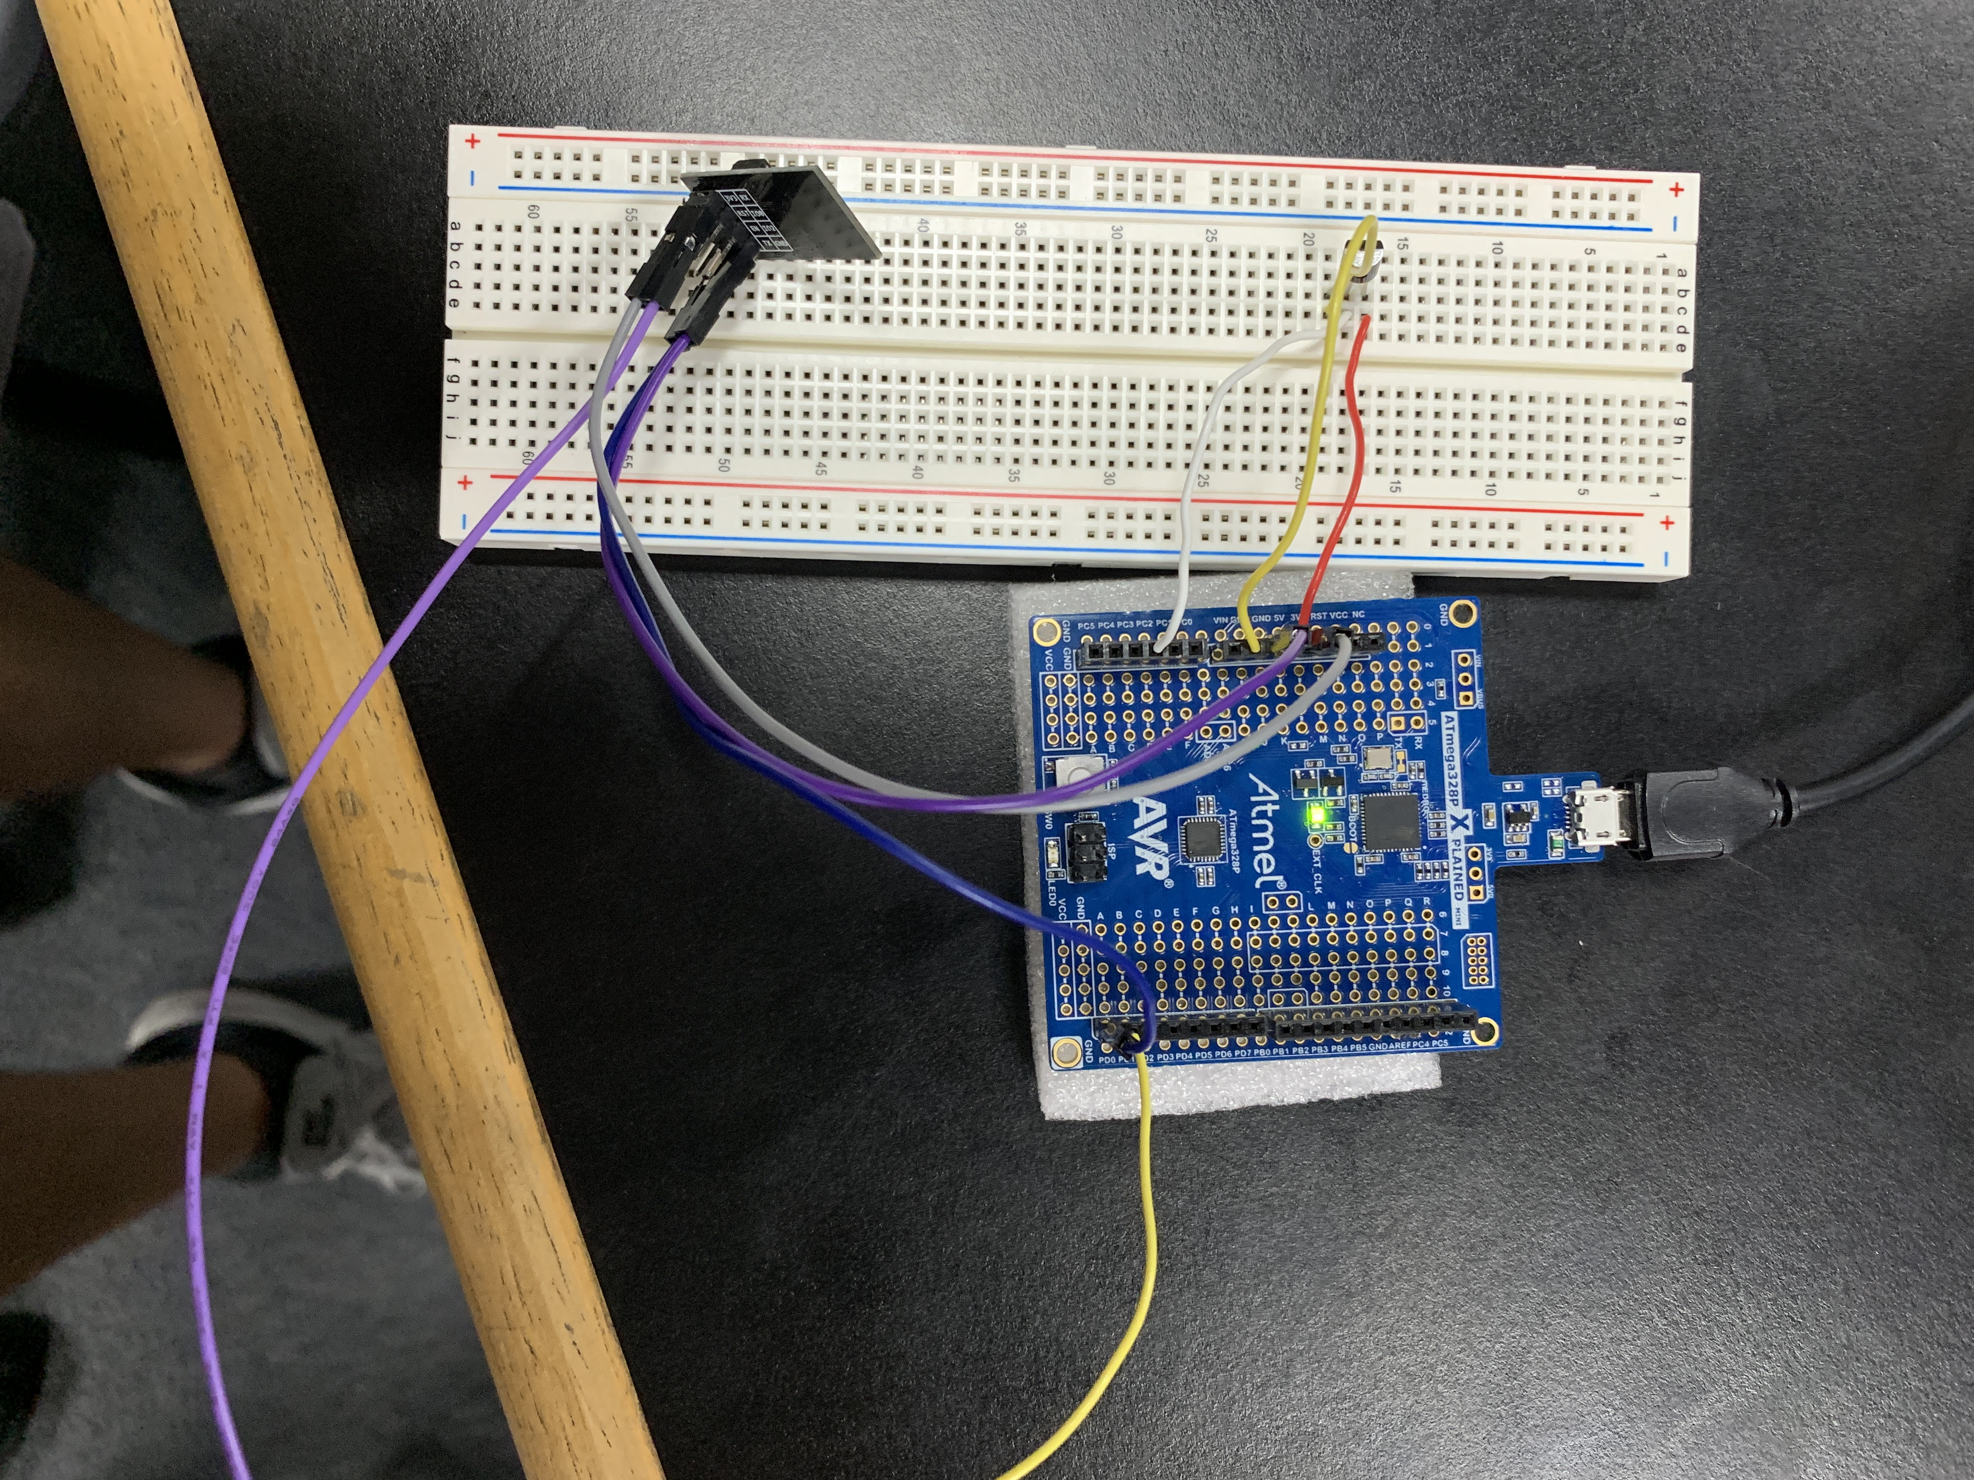

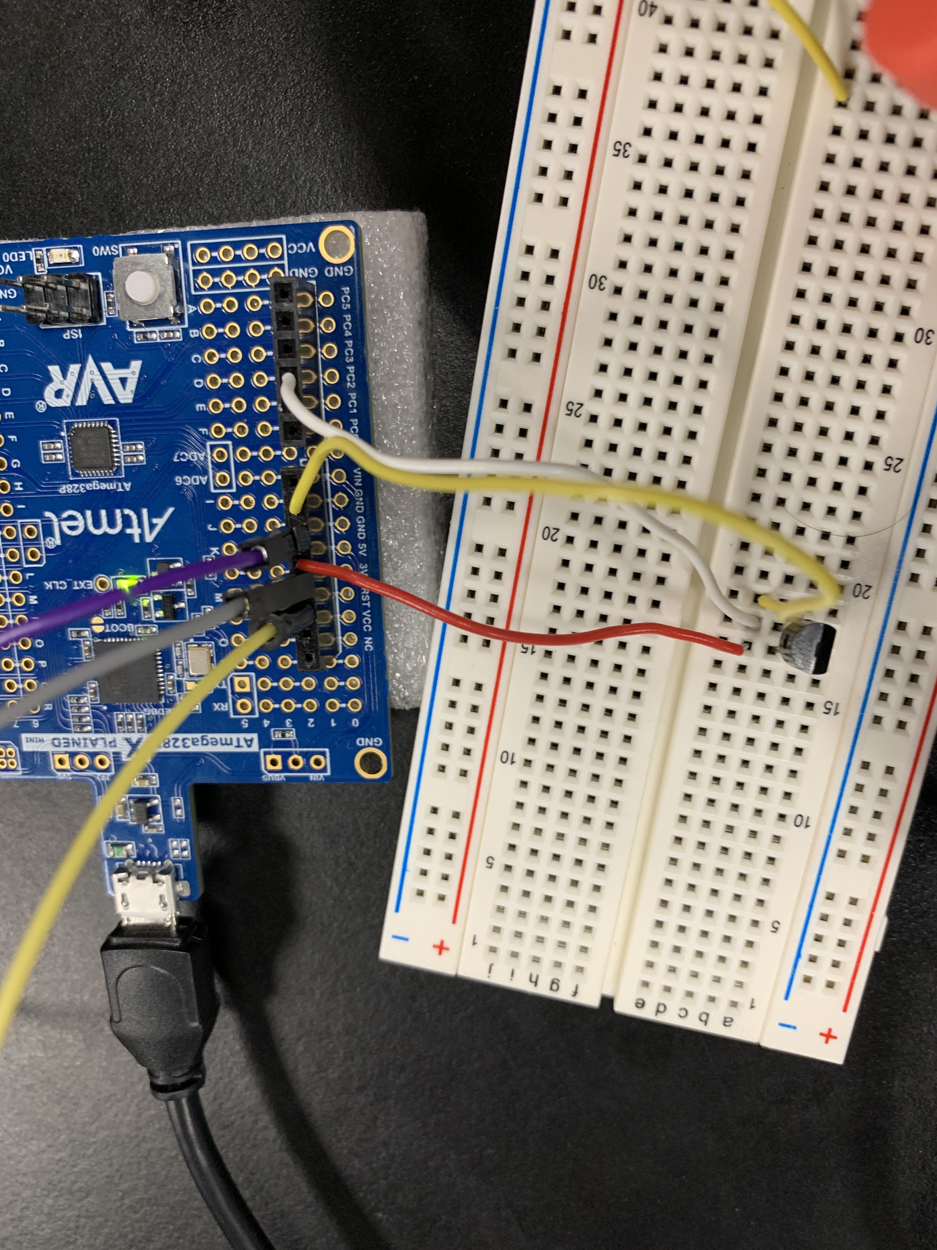

1. **VIDEO LINKS OF EACH DEMO**

<https://youtu.be/6o4hQh2CRiw>

1. **GITHUB LINK OF THIS DA**

<https://github.com/martiv6/>midterms/Midterm_1

**Student Academic Misconduct Policy**

<http://studentconduct.unlv.edu/misconduct/policy.html>

“This assignment submission is my own, original work”.

Victor Martinez